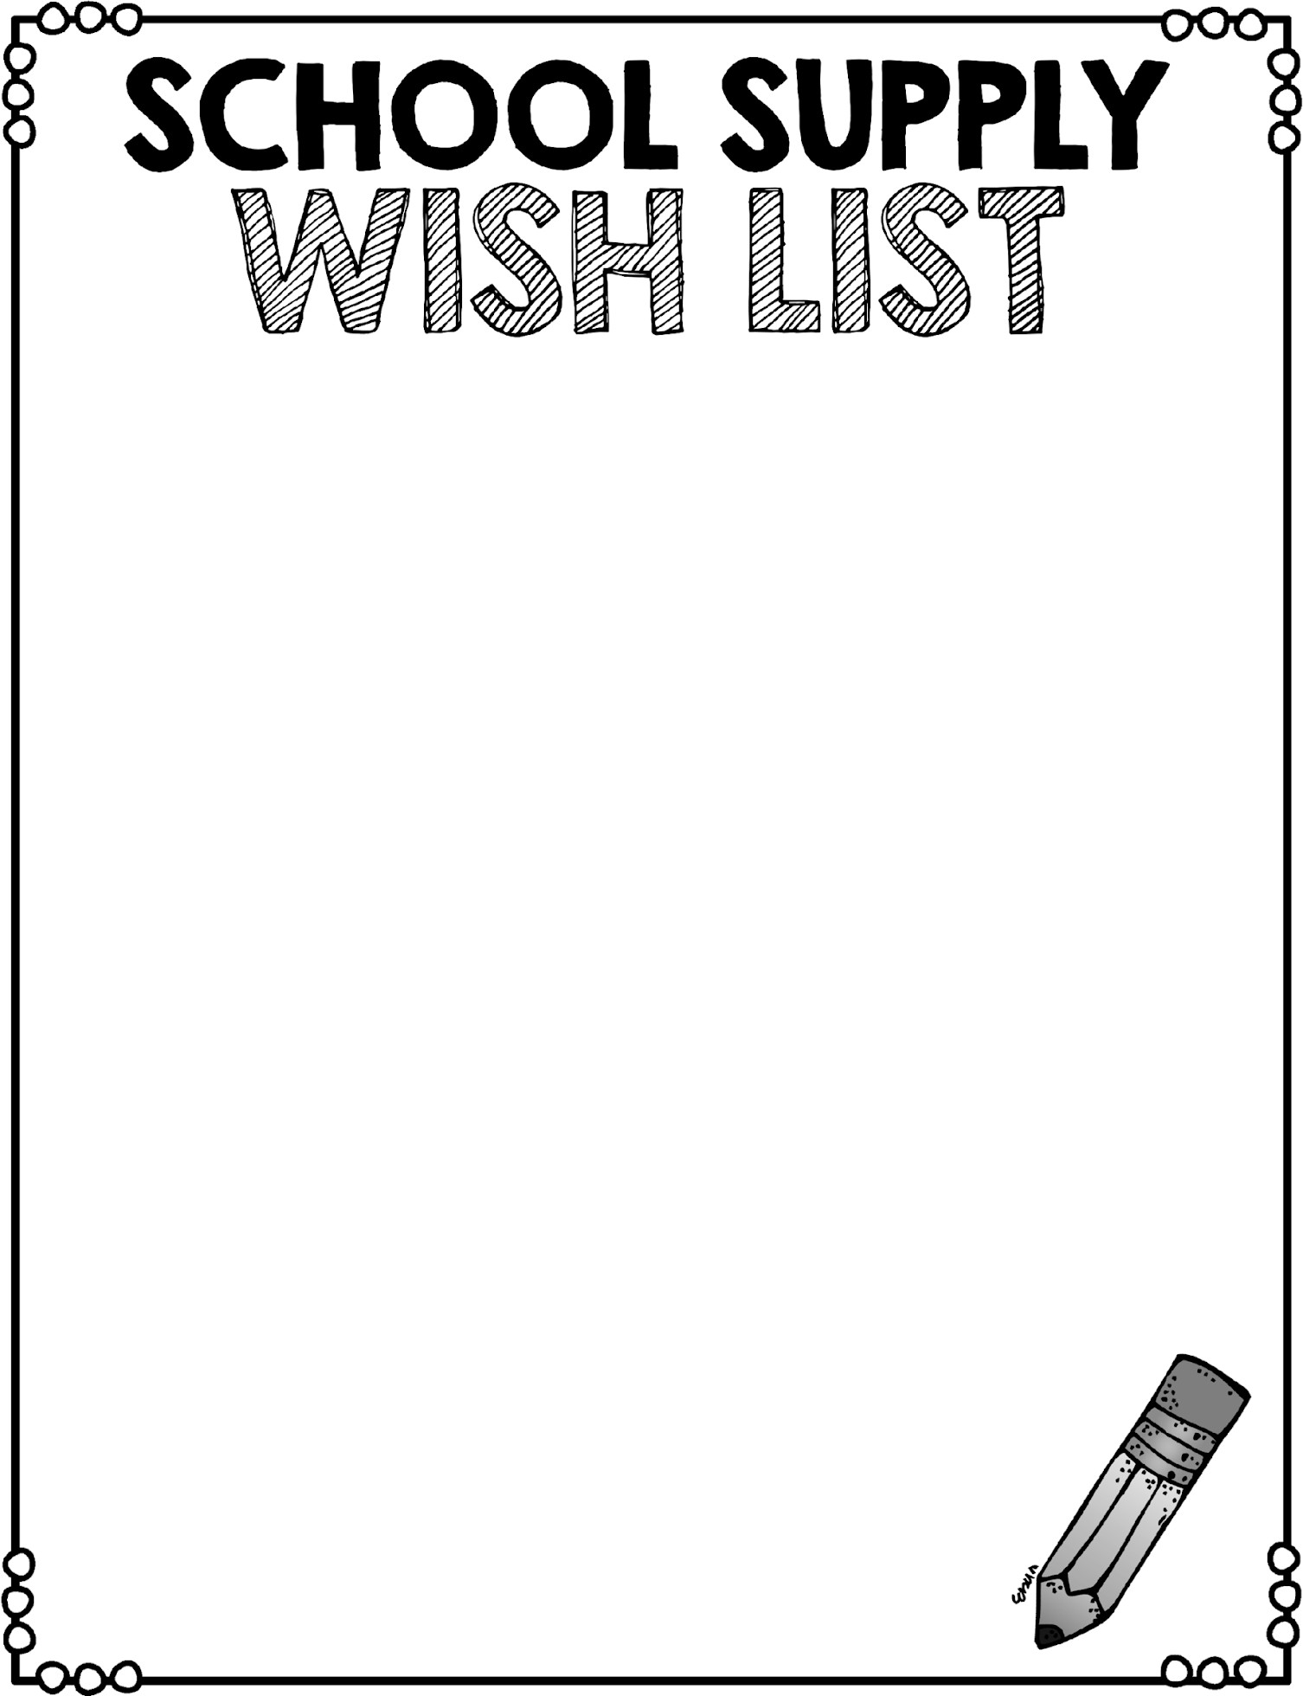
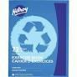
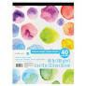

We are a classroom that pools our supplies into community supplies.
Once all supplies have been received from all students, we put them together so that no individualized pencil boxes/areas are needed.
We graciously ask that you please NOT label supplies as they will be used by our entire community day by day. Thank you SO much!

These are the supplies each student should bring UNLABELLED to their kindergarten orientation appointment in September:

- 1 pair of non marking gym shoes, velcro only please (no laces)
  - 1 paint shirt (an old long sleeve shirt will do just fine)
- 1 backpack large enough to hold a book, lunch box and jacket
  - 4 large glue sticks
  - One box of large Ziploc bags
  - 5 regular black Sharpies (also says fine point on the box)
    - 3 Dry Erase markers in any colour
    - 8 CRAYOLA markers of any colour
    - 2 blank scribblers to use as a doodle book. They look like this:

- 1 small blanket (only big enough to sit on) that can be kept in your child’s locker all
year long
  - 2 pieces of large white poster board (available at dollar stores)

Here are a few back to school supplies that our class is putting
on our “Wish List” this year THAT ARE NOT MANDATORY.
Please do not feel like you have to run out and buy all of these items! If you have any of them at home and are able to donate, we would love some of the goods listed below.
~Sharpies of all colours
)
~Scrapbook Paper and Watercolor paper (It looks like this at Michaels
~Stickers
~Playdoh
~300 piece puzzles
~Tempera Paint Sticks (available at Michael’s and Dollarama)
~Mr. Sketch Scented Markers

If you are unable to donate at this time, no worries!
I ask for different supplies to be sent in throughout the year.

