That's MY School!

Children of St. Martha Elementary School Supply list for Grades 2&3
2024-2025
Please label all items with your Child's name before bringing them to school


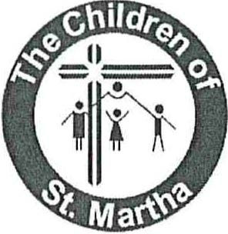
13pk ruled 7mm, 32pg exercise book
7 duo-tang folders (red, green, yellow, orange, blue, black, purple)
1 plastic duo-tang
2 large UHU glue sticks
1 pkg. of 24 pencil crayons
1 pkg. washable felt markers
1 pkg. thin dry erase markers (Expo brand last the longest)
24 Hb pencils (already sharpened)
1 pkg. oil pastels
1 black sharpie felt pen
3 erasers
1 plastic ruler
1 pair metal blade scissors (pointed tip)
1 pencil box or case
1 pencil sharpener (that holds the shavings)
1 set of headphones-any size for !pad/computer use
1 box of Kleenex
1 roll of paper towel
1 pair of runners (indoor shoes) no black soles

1 backpack
1 re-fillable water bottle

