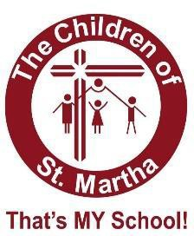
Children of St Martha Elementary School Supply List for Grade 1 students 2024-2025

12 Hb pencils
4 white erasers
2 plain (unlined ) Hilroy scribblers
4 dotted half interlined Hilroy (12155) notebooks
1 bottle of white glue
10 UHU glue sticks (large size)
1 24pack of crayons
1 24 pack of pencil crayons 1 pack of washable markers 1 box of Crayola oil pastels 1 sharpie pen
1 metal blade scissors
1 highlighter
2 pencil boxes or cases (1 for crayons & 1 for felts)
1 pkg. thin dry erase markers (Expo brand)
1 clipboard
1 set of headphones any size or type (for computer and ipad use) Indoor runner for gym and inside school use (non-marking soles) 1 re-useable water bottle
3 duo-tang A box of ziplock baggies (any size)
10 page protectors
3 boxes of tissues A small box of band-aids A change of clothes to be left in their backpack
Please do NOT send a pencil sharpener
Please label all items with your child’s name before bringing them to school.

